Configuration of Azure Customer:

Select Azure Active directory and Click on App Registration.

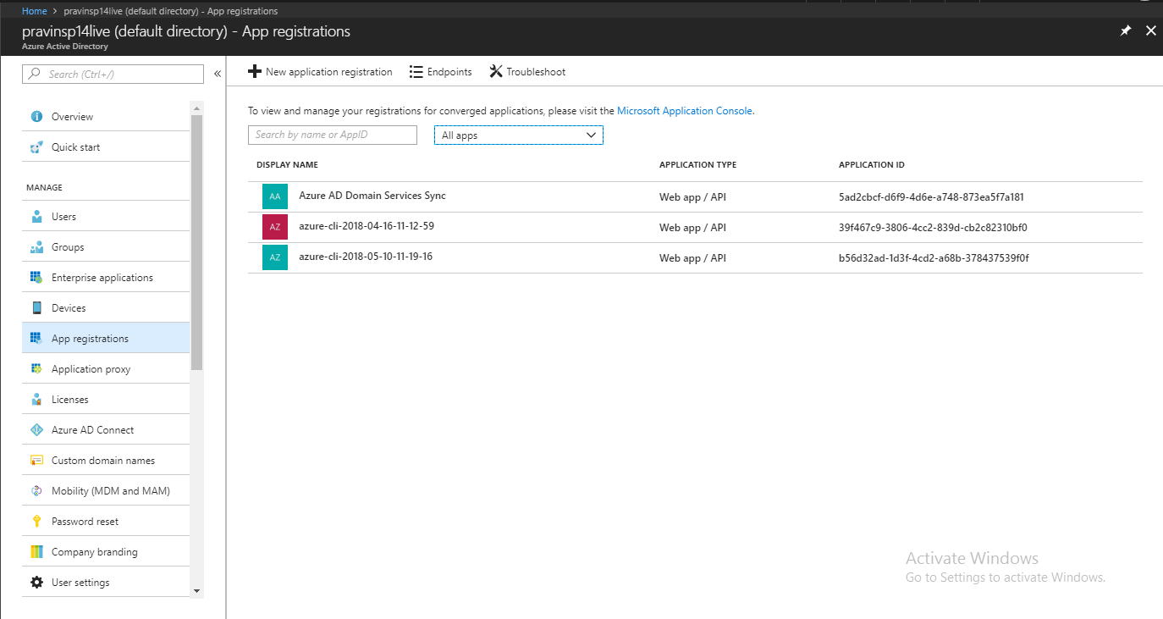

Click on +New Application regidtration.

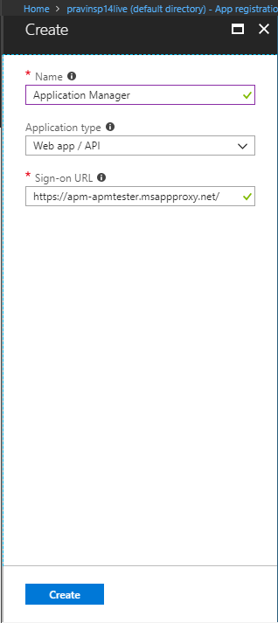

After App Registration we need to collect Client Id, Tenant Id and App Key. Fallow the below steps.

After Creating Application Manager we can find Application ID or Client ID copy it in a notepad.

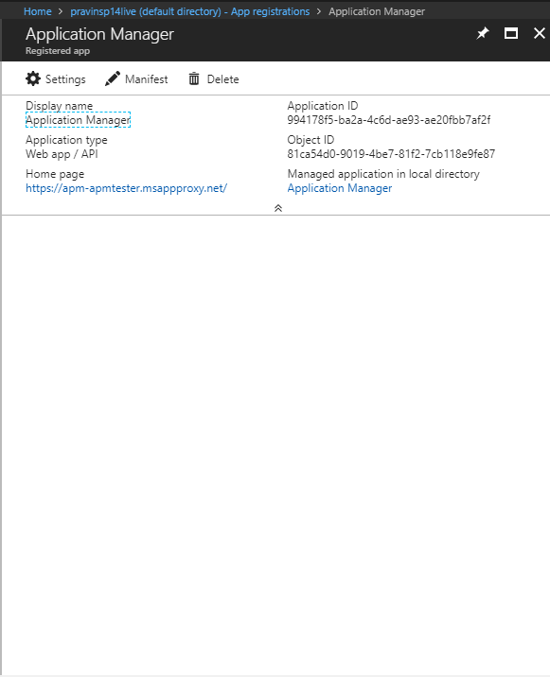

Click on Settings in Application Manager we can find Key. We need to generate a One Key prove a name and Key Expires time and click on Save. After Saving the Key will be generated copy to Notepad.

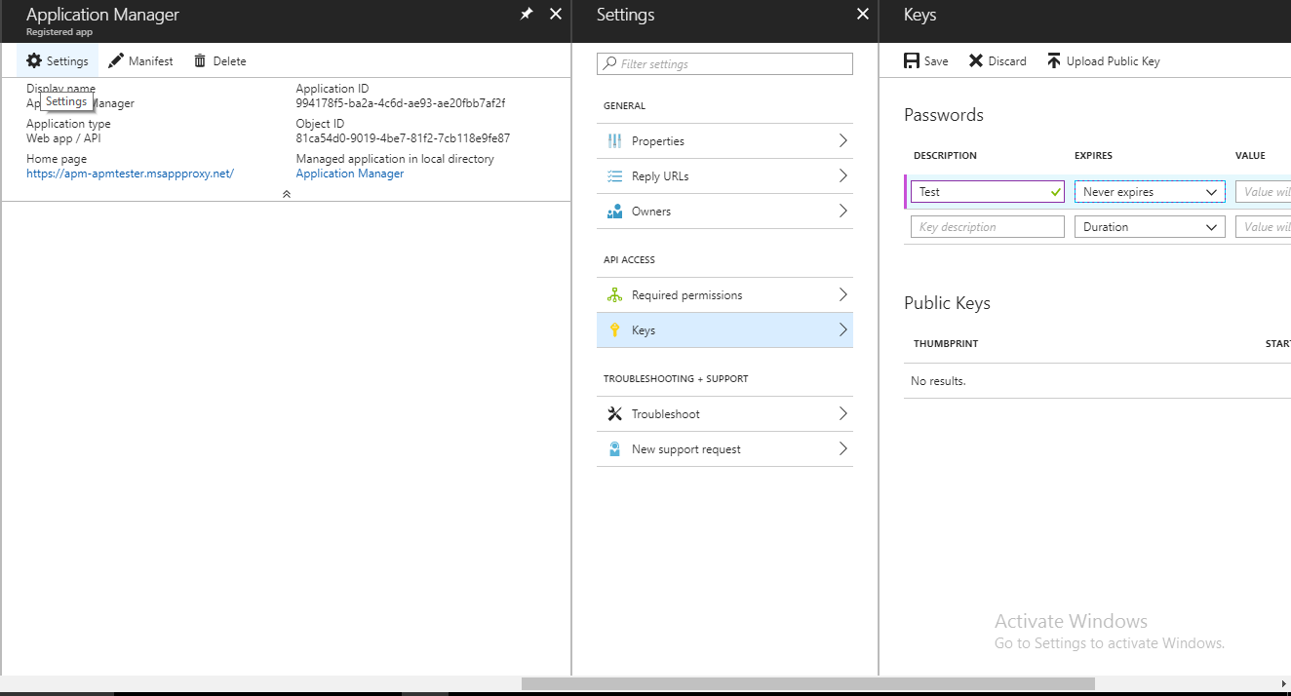

After Copying client ID and App Key Go to the Subscription and select Access Control.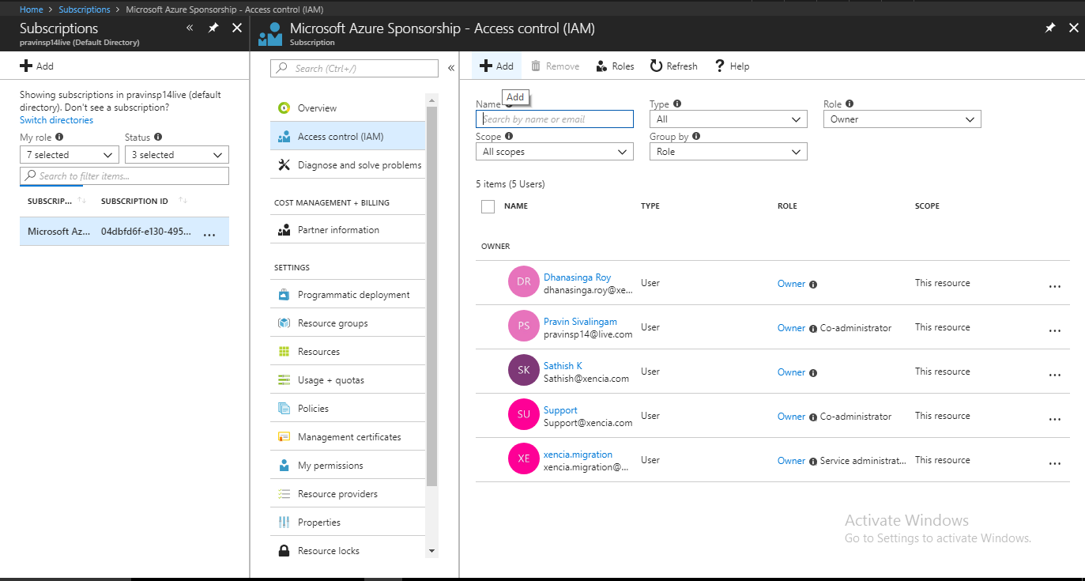

Click on +Add Register the Application Manager by providing the Owner Permission and click on Save.

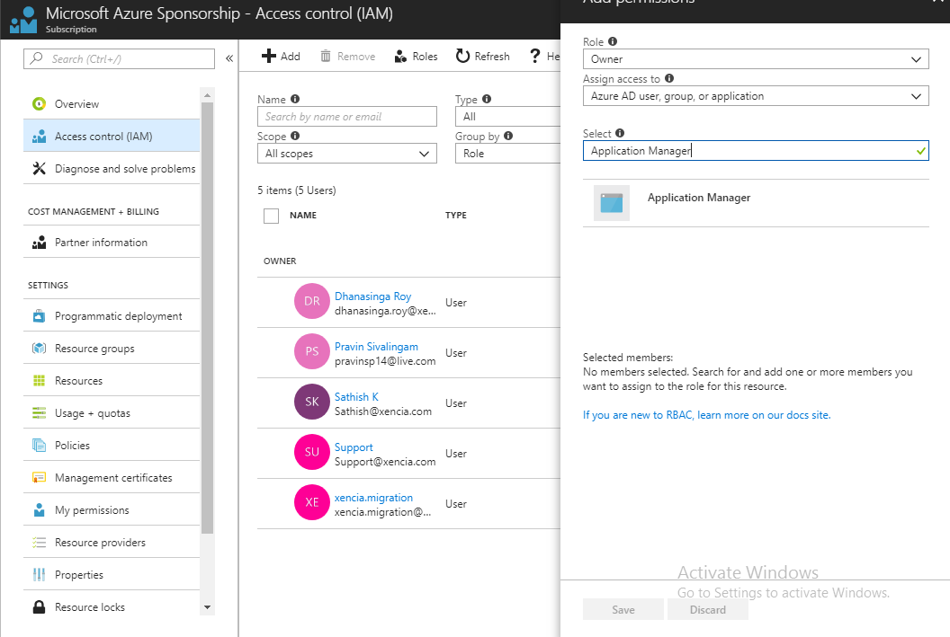

After registering Select Azure Active Directory to get the Directory ID or Tenant ID.

In Azure Active Directory click on Properties we find a Directory ID copy in Notepad.

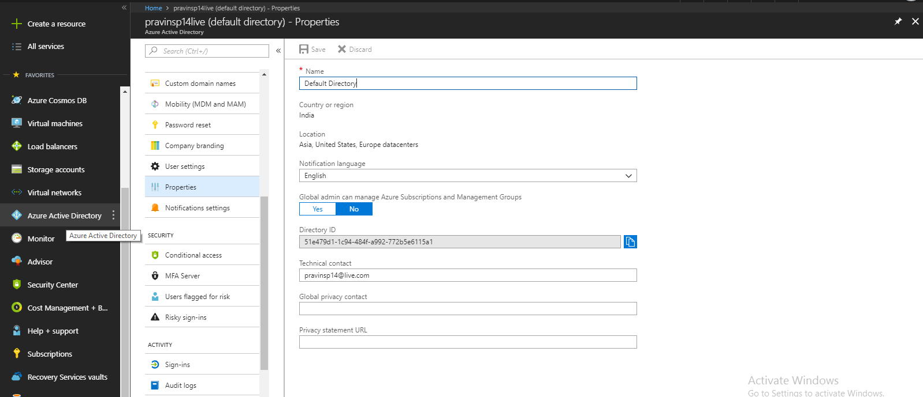

This Finishes the requirements in Azure Portal.